Investigating
Early Societies through the

Aga Khan Museum

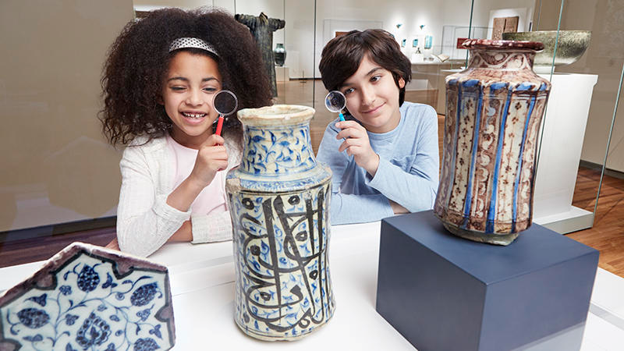
These Curriculum-linked resources were created in partnership with the Aga Khan Museum,
the Ministry of Education and the Ontario Elementary Social Studies Teachers Association and
were inspired by the Museum’s Permanent Collection. Object information and images courtesy
of the Aga Khan Museum.

Investigating
Early Societies through the

Big Ideas
- The environment
had a major impact
on daily life
in early societies.

Guiding Questions

- How can
museum artefacts
help us learn
about early
societies?

- What is the interrelationship between the
environment
and life in
early societies?

- What were some connections
between the local environment
and art, religion
or spirituality?

- How did where
people live impact
how they lived?

- In what ways did
the environment
influence early
societies?

Aga Khan Museum

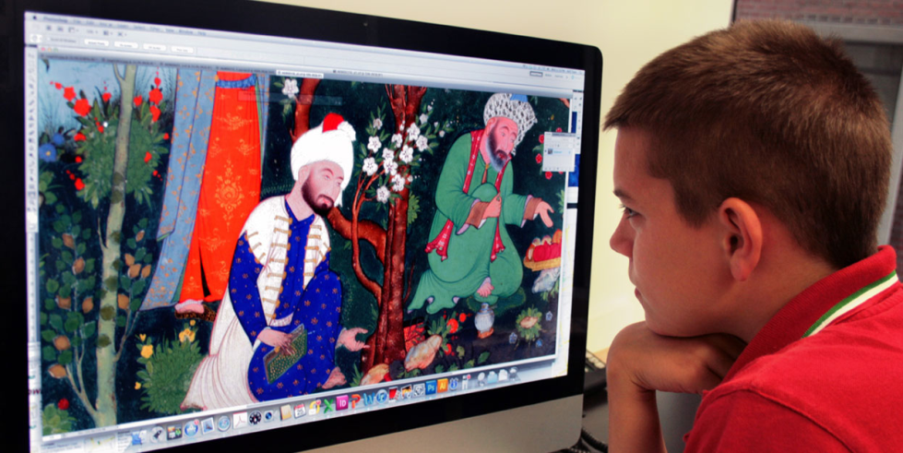
Searching a computer image of a painted manuscript from the
Aga Khan Museum for clues.

In Grade 4 social studies, students will develop their understanding of how we study the past, as they use various methods to examine, social organization, daily life and the relationship with the environment in different societies that existed to 1500 CE…. Students will build on what they have learned in earlier grades, using visual evidence, primary and secondary sources, and thematic maps to investigate a number of early societies from different regions and eras representing different cultures.
Revised (2018) Social Studies, History and Geography Curriculum

Investigating
Aga Khan Museum

Early Societies through the

- What role did
religion or
spiritual beliefs
play in the daily
life of early
Islamic societies?

- In what ways
were beliefs
connected to the society’s view of
and relationship
with the
environment?

- What does artwork
reveal about the
spiritual beliefs
and practices
of a society?

- What might
architecture
tell you about
society’s
relationship
with the natural
environment?

Overview:
In this unit, students engage in social studies inquiry to investigate the interrelationship between early societies and the environment. Through examination, interpretation and analysis of artefacts within the Aga Khan Museum, students draw conclusions about the interrelationship, then, design a project to communicate their findings.

By the end of the unit, students will have engaged in all steps of social studies inquiry, with many opportunities along the way to practice, develop and reflect on the individual inquiry processes and skills.

Lessons within the Unit:
Lesson 1: Making Observations & Formulating Questions
Lesson 2: Gathering & Organizing Information about
Early Societies
Lesson 3: Evidence
Lesson 4: Evaluating Evidence & Drawing Conclusions
Lesson 5: Communicating the Results of an Inquiry

Curriculum Expectations covered within the Unit
Social Studies – Strand A. Heritage and Identity:
Early Societies to 1500 CE

A2 Use the social studies inquiry process to investigate ways of life and relationships with the environment in a few early societies (to 1500), including at least one First Nation and one Inuit society, with an emphasis on aspects of the interrelationship between the environment and life in those societies.
A2.1 Formulate questions to guide investigations into ways of life and relationships with the environment in a few early societies, including at least one First Nation and one Inuit society, with an emphasis on aspects of the interrelationship between the environment and life in those societies.

Social Studies
Thinking Concepts

These lessons focus
on the Social Studies Thinking Concept Interrelationships.
The thinking concepts
act as a lens for
students to
question, and think
critically about what
they learn throughout
social studies
investigations.

Spatial Skills
Students should have opportunities to
identify the locations
of early Islamic
societies on maps
and globes and
analyse maps
related to early
societies’
relationship
with the
environment.

A2.2 Gather and organize information on ways of life and relationships with the environment in a few early societies, including at least one First Nation and one Inuit society, using a variety of primary and secondary sources in both print and electronic formats.
A2.4 Interpret and analyse information relevant to their investigations, using a variety of tools.
A2.5 Evaluate evidence and draw conclusions about ways of life and relationships with the environment in a few early societies, including at least one First Nation and one Inuit society, with an emphasis on aspects of the interrelationship between the environment and life in those societies.
A2.6 Communicate the results of their inquiries, using appropriate vocabulary and formats.

Prior Knowledge for each Lesson
Lesson 1
Students should have understanding of:
- primary sources;
- secondary sources;
- the Social Studies Thinking Concept, Interrelationships.

Lesson 2
Students should have understanding of:
- how to create jot notes.

Lesson 3
Students should have:
- some experience interpreting and analysing information as part of social studies inquiry;
- some understanding of what constitutes evidence;
- experience conducting internet searches;
- experience accessing trustworthy websites.

Lesson 4
Students should have an understanding of:
- how to use critical thinking to make a decision based on evidence.

Big Ideas
- Canada is made up of various communities that have diverse traditions and celebrations.
- The traditions that we celebrate today have developed over the generations.

Guiding Questions

- How does an understanding of unique individuals and groups help us appreciate the diversity in our community?
- Why should we respect the diverse cultures and traditions in the communities in which we live?

Lesson 1:

Formulating Questions

Making Observations &

Learning Goal
- We are learning to examine museum artefacts and
formulate questions based on our observations of
the artefacts to
help us discover interrelationships between ways of
life and the
environment in
early societies.

Suggested Success Criteria

I know I am successful
when I can:

- make observations
based on an
artefact or image;
- generate
wonderings about
an artefact;
- turn my wonderings
into questions that
help to further my inquiry;
- apply the Social
Studies Thinking Concept, Interrelationships
when formulating
my questions.

Curriculum Expectations
- A2, A2.1

Minds On

Early Societies

Early societies are those societies which existed up to 1500 CE. While some early societies may have had common elements, not all early societies were the same. However, we can surely say that the environment had a major impact on daily life in all early societies. Consider then, what is the interrelationship between the environment and the ways of life in early societies?

Introducing the Aga Khan Museum!

The Aga Khan Museum is North America’s first museum dedicated to Islamic art and cultures. The Museum has a collection of artefacts from a broad range of locations, dating back to the 8th century that can help us learn about some early societies. Take a look at this map (see below) to see some of the artefacts from the Museum's collection and their places of origin.

Lead the class in a discussion about the map. The following questions may be used to guide the discussion.

- What do you notice about the kinds of artefacts plotted on the map?
- What do you know about any of these artefacts?
- What do you notice about the various geographical locations identified on the map?
- What do you know about any of these geographical locations?
- What doesn’t this map tell us?

Question: What do these artefacts and geographical locations have in common?
Answer: All of these artefacts come from various time periods and geographic areas where Muslim societies were predominant. And, all of these artefacts can be found at the Aga Khan Museum!
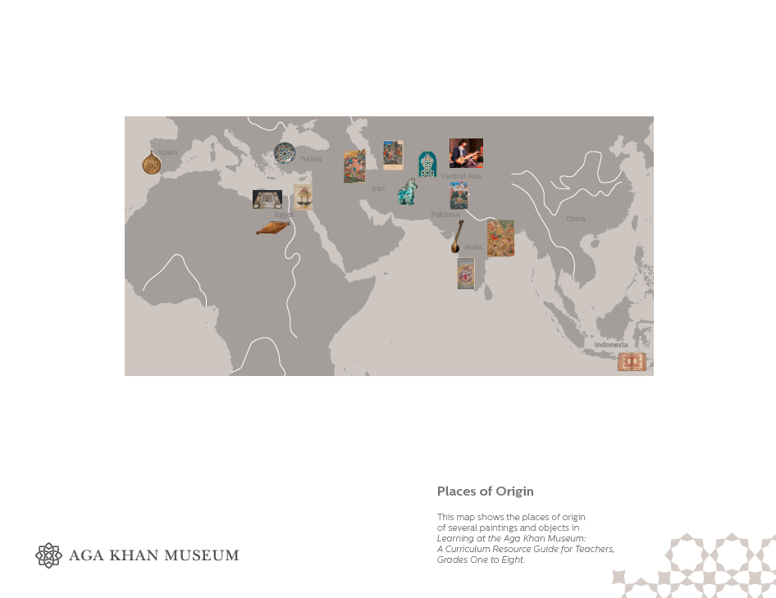

Vocabulary
- artefact
- predominant
- commentaries
- Islam
- Muslim
- Islamic art
- interrelationship
- primary sources
- secondary sources
- civilizations
- spiritual
- wonderings

Teacher Notes

Minds On

Minds On should:

- clarify that
artefacts are
evidence of the
way people lived,
and it can be
helpful to
examine them
throughout an
inquiry;

- identify some of
the processes that
social scientists,
like historians utilize
in their work;

- introduce students
to the collection of artefacts at the
Aga Khan Museum.

Explore the Aga Khan Museum and its collection.

Welcome

The Aga Khan Museum houses a vast collection of art and artefacts spanning over one thousand years of history. Allow students to view images, read commentaries on the artefacts and learn about what the Aga Khan Museum has to offer.

*Consider a field trip if in or near the Toronto area.

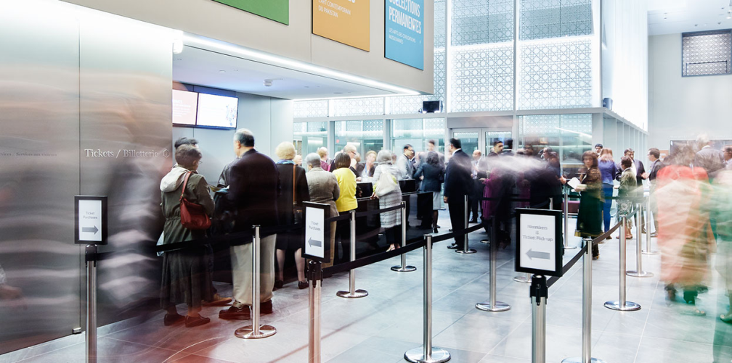

Visiting the Aga Khan Museum

What is the Museum’s Mission?

The Museum’s mission is to help people understand and appreciate the many contributions made by Muslim civilizations.

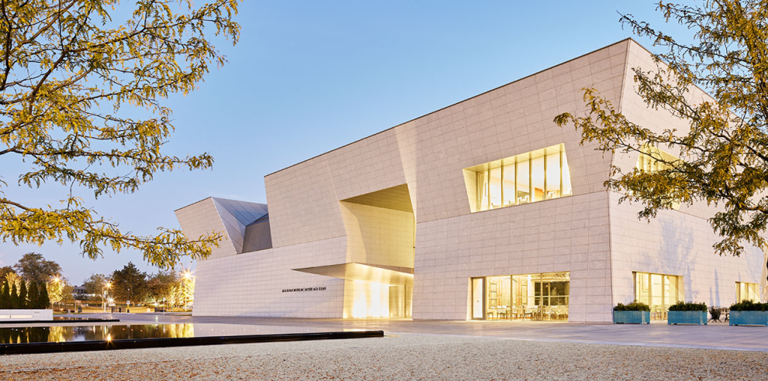

The Aga Khan Museum

Teacher Notes

When discussing the question, How did
where people live
impact how they
lived?, explicitly
identify what is
meant by ways of
life/how people lived
and the environment
and how the two
are related.

Who is the Aga Khan?

The Aga Khan is the 49th spiritual leader of the Shia Ismaili Muslims, who number between 12 and 15 million people. He is the founder of the Aga Khan Museum. The artefacts in the Museum were collected by His Highness the Aga Khan and his family.

His Highness, Prince Shah Karim Al Hussaini, the Aga Khan.

What is Islam?

Islam, like Judaism and Christianity, is a religion. Its followers are called Muslims. The holy book of Islam is the Qur’an.

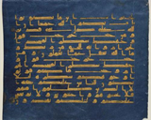

Folio from a Qur’an Manuscript
Q2: 148 – 150
North Africa, ca. 9th-10th century
Ink, opaque watercolour, gold and silver on blue-dyed parchment
28.7 x 35.6 cm
The Aga Khan Museum, AKM248

What is Islamic art?

Islamic art refers to visual arts that are created in lands where Islam is the main religion.

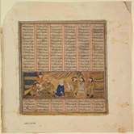

Bahram Gur at the house of Mahyar the Jeweller
Folio from a manuscript of Shahnameh (Book of Kings),
by Firdausi (d. 1020)
Western Iran, late 13th or early 14th century
Opaque watercolour, ink, and gold on paper
24 x 19.2 cm
The Aga Khan Museum, AKM16

Interrelationships between Life and the Environment

Each museum artefact holds clues that identify information about the ways of life and the environment in early societies. Suggest that students frequently ask questions while investigating the Museum (online or in person) that help reveal that where people lived had an impact on how they lived.

Teacher Notes
Action
Action should model:
- how to make observations that generate
wonderings;

- how to use those wonderings to
formulate questions according to the
criteria on interrelationships.
It is important for
the teacher to lead
and model this section
of the lesson.

It is also important to
share with students
that they are engaging
in the work and
disciplinary thinking
of historians.

Review the See-Say-
Wonder protocol
with students, and
model the protocol
as needed. Allow
appropriate time
for student
observations
and partner sharing.

Action
Working with Artefacts

Artefacts are sources of information that can provide clues
about the way early societies lived and interacted with their environment. When we use a variety of sources to make
observations, generate wonders and turn our wonderings
into questions, we are doing the work of social scientists, like historians. In our investigations of early societies through the
Aga Khan Museum, we will be working with primary and secondary sources.

Beginning an Inquiry
Lead the class in a knowledge building discussion that addresses the question, How did where people live impact how they lived?
Making Observations using See–Say–Wonder
Distribute the A1 Formulating Questions Organizer to each student. Students examine the following artefact, an astrolabe, from the Museum’s collection.
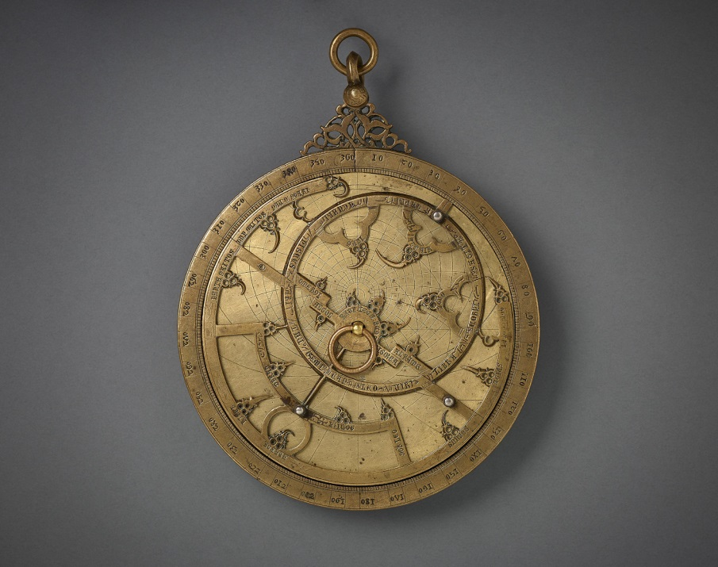
Spain, 14th century
Bronze, engraved and inlaid with silver
Diameter: 13.5 cm
The Aga Khan Museum, AKM611

Teacher Notes
Demonstrate how to
turn a wondering
about the artefact into
a question that
addresses either the environment, ways
of life or the
interrelationship
between ways of life
and the environment.

For example,

Wondering:
I wonder what this
object is used for…

Question:
How did people use
this object?

Wondering:
I wonder what
materials were used
to make this object…

Question:
What raw materials
were used to make this object, and how were
they gathered?

Wondering:
I wonder who might
have owned this object…

Question:
Why would someone
need this object at this
time in history?

An astrolabe is an early form of astronomical computational device that was widely used in classic antiquity, the European Middle Ages and Renaissance, as well as the Islamic Golden Age. An astrolabe enabled the user to determine the positions of the sun, moon, planets and stars with respect to astrological houses. This astrolabe is of particular interest because of its inscriptions in Latin, Hebrew and Arabic, which indicates its many owners throughout history.
On the A1 Formulating Questions Organizer, students answer the following questions based on their observations:
- What do you see?
- What makes you say that?
- What does it make you wonder?
Students repeat the process for two additional observations and record on the Organizer, then, share their ideas with a partner.
Lead the whole class in a knowledge building circle on students’ observations. On a piece of chart paper, record all student wonderings on chart paper. Group together similar wonderings.

Formulating Questions
Suggest that students turn their wonderings into questions. Demonstrate by using the following criteria to formulate
questions based on student wonderings.

This criteria addresses the Social Studies Thinking Concept, Interrelationships:
- Does your question seek to reveal ways of life?
- Does your question seek to reveal information about the environment?
- Does your question seek to identify aspects of the interrelationship between ways of life and the environment?

Teacher Notes
Consolidation

Provide students with support and feedback
as they formulate their questions. Where
needed, provide small
group instruction to
model formulating questions.

Select students to
model the feedback
process for using the criteria, before forming student partnerships.

Teachers may opt to
collect students’
A1 Organizers to
provide additional
feedback.

Consolidation
Students formulate three questions based on their own or others’ wonderings. Questions are placed in the A1 Organizer, and shared with a partner. Partners should be encouraged to select questions that best relate to the criteria and provide feedback for improvement.
Students will revise the questions in their A1 Organizers, having applied the peer feedback.

Students may use a highlighter to identify their best question.

Assessment
Consolidation task feedback “look fors” are provided on the
A1 Formulating Questions Organizer. Add or adjust
the “look fors”, as appropriate.

Investigating Early Societies through the AGA KHAN MUSEUM

A1: Formulating Questions Organizer
What is the interrelationship between the environment and ways of life in early societies?
Artefact:
Observation 1:

What do you see?
What makes you say that?
What does it make you wonder?
Observation 2:

What do you see?
What makes you say that?
What does it make you wonder?
Observation 3:

What do you see?
What makes you say that?
What does it make you wonder?
Turning My Wonderings Into Questions

- Does your question seek to reveal ways of life?
- Does your question seek to reveal information about the environment?
- Does your question seek to identify aspects of the interrelationship between ways of life and the environment?

Question 1:

Question 2:

Question 3:

Investigating Early Societies through the AGA KHAN MUSEUM

Peer Feedback provided to ______________________________________________

- Where am I going?
- You have completed 3 observations.

- You have not completed 3 observations.

- You have turned all of your wonderings into questions.

- You have not turned all of your wonderings into questions.

- How am I doing?
- All of your questions meet the criteria for interrelationships.

- Some of your questions meet the criteria for interrelationships.

- Your questions do not meet the criteria for interrelationships.

- Where to next?
- Make additional observations to generate further wonderings and questions.

- Consult with a peer on his/her observations.

- Revise your questions to meet the criteria for interrelationships.

- Identify your best question.

Peer Feedback provided by ______________________________________________
Lesson 2:

about Early Societies

Learning Goal
- We are learning
to gather and
organize
information about artefacts at the
Aga Khan Museum
as we investigate
the relationship
between ways of
life and the
environment in
early societies.

Suggested Success Criteria

I know I am successful
when I can:

- locate information
from primary and secondary sources;
- gather and record information in a
variety of ways
(making observations
to formulate
questions,
transferring direct information,
using jot notes);
- create an organizer to support my inquiry.

Curriculum Expectations
- A2, A2.1, A2.2

Gathering & Organizing Information

Minds On

In Lesson 1: Making Observations & Formulating Questions, students examined a specific artefact, selected by the teacher, from the collection at the Aga Khan Museum. In their examinations, students have been encouraged to consider and question the relationship between life and the environment in early societies.
Now students are given choice in selecting an artefact from the Aga Khan Museum’s collection to assist them in answering their inquiry questions.
With over one thousand items to choose from, they might be wondering where to start.
Students begin by completing the Before Reading section of the A2: Anticipation Guide (below). The Anticipation Guide provides an opportunity for students to think about the types of artefacts they will be exploring through the Aga Khan Museum Collection.
When students are finished with this portion of the Anticipation Guide, they will visit the Aga Khan Museum website https://www.agakhanmuseum.org/collection/collection-highlights ) to preview the collection.
At this time, students return to the A2. Anticipation Guide and complete the After Reading section as they preview the collection.
Ensure that students select an artefact from early societies within the time frame guidelines of the curriculum expectation (to 1500 CE).

Vocabulary
- artefact
- museum
identification label
- museum
commentary
- ceramics
- luxury objects
- painted
manuscripts
- illuminated
manuscripts

Teacher Notes

Minds On

Minds On should:

- demonstrate that
artefacts are
sources which
can be examined
throughout
an inquiry;

- deepen students’
knowledge and
understanding of
the collection of
artefacts at the
Aga Khan Museum.

Some students may be overwhelmed with the number of artefacts available. Here are some suggestions for artefacts that are best suited to help students gather and organize information that will inform their inquiries:
Ceramics
Pharmacy Jars AKM567
Pilgrim Flask AKM540

Luxury Objects
Bead AKM618
Ivory Horn AKM809
Robe AKM677
Box AKM652

Painted Manuscripts
Bijan takes the reins to aid Gustaham AKM64
The combat of Furuhil and Zangula AKM84
Bahran Gur kills a rhino in India AKM54

Science and Learning
A Blood Measuring Device AKM11
The Canon of Medicine AKM510

Once students have previewed the collection, and identified three possible artefacts to explore, they choose one.
Encourage students to be mindful that the date of the artefact is not later than 1500 CE. Circulate and consult with students regarding their choices.
If possible, use a collaborative online platform, such as Google Docs or Google Classroom to allow students to post:
- the name of their artefacts, including the AKM number;
- a picture of the artefact; and,
- explain why they selected this artefact for their inquiry.
Encourage students to respond to the post of one of their peers. They can use the following sentence-starter, if helpful:
Thanks for sharing your selection, (insert name). I located your artefact on the Museum’s website and also found it to be interesting because...

Investigating Early Societies through the AGA KHAN MUSEUM
A2: Anticipation Guide
Before Reading:  Make some predictions about the kinds of objects you may find in each category  of the Aga Khan Museum’s collection. Why do you think that? |  | After Reading:  How accurate were your predictions?  Did anything surprise you? Explain.
Architectural Decoration
Calligraphy and Illumination
Ceramics
Luxury Objects
Metalwork
Painted Manuscripts
Qur’ans
Science and Learning
Select three artefacts that could best reflect the interrelationship between ways of life and the environment.

1.

2.

3.

Action

Teacher Notes

Action

Action has two parts:
- Making observations
to formulate
questions;

- Gathering and
organizing students’ information.

Remind students to
reflect on what they
learned in Lesson 1
on making observations
and generating
questions, as needed.

Making Observations and Formulating Questions

In Lesson 1, students gathered information about the astrolabe by making some initial observations and wonderings. Then, they formulated questions from wonderings using the following criteria:
- Does the question seek to reveal ways of life?
- Does the question seek to reveal information about the environment?
- Does the question seek to know the interrelationship between ways of life and the environment?

Students repeat the process with their selected artefact.
Distribute the A2 Formulating Questions Organizer for students to record their work (see below).
When finished, have students pair up with a partner to share their questions. Students should discuss how questions best relate to the criteria for interrelationships and offer each other feedback for improvement.
Allow time for students to revise their questions according to peer feedback. Ensure that students submit their A2 Formulating Questions Organizer to the teacher.
Investigating Early Societies through the AGA KHAN MUSEUM

A2: Formulating Questions Organizer
What is the interrelationship between the environment and ways of life in early societies?
Artefact:
Observation 1:

What do you see?
What makes you say that?
What does it make you wonder?
Observation 2:

What do you see?
What makes you say that?
What does it make you wonder?
Observation 3:

What do you see?
What makes you say that?
What does it make you wonder?
Turning My Wonderings Into Questions

- Does your question seek to reveal ways of life?
- Does your question seek to reveal information about the environment?
- Does your question seek to identify aspects of the interrelationship between ways of life and the environment?

Question 1:

Question 2:

Question 3:

Investigating Early Societies through the AGA KHAN MUSEUM

Peer Feedback provided to ______________________________________________

- Where am I going?
- You have completed 3 observations.

- You have not completed 3 observations.

- You have turned all of your wonderings into questions.

- You have not turned all of your wonderings into questions.

- How am I doing?
- All of your questions meet the criteria for interrelationships.

- Some of your questions meet the criteria for interrelationships.

- Your questions do not meet the criteria for interrelationships.

- Where to next?
- Make additional observations to generate further wonderings and questions.

- Consult with a peer on his/her observations.

- Revise your questions to meet the criteria for interrelationships.

- Identify your best question.

Peer Feedback provided by ______________________________________________

Gathering Information and Organizing Information
Show students the astrolabe artefact from Lesson 1.
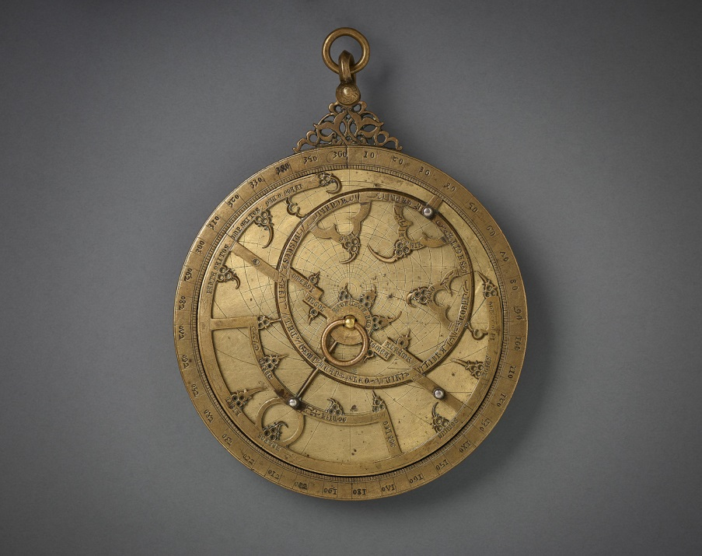
Spain, 14th century
Bronze, engraved and inlaid with silver
Diameter: 13.5 cm
The Aga Khan Museum, AKM611

Suggest that the Aga Khan Museum website has additional information about this artefact. Share the following information with students:
Museum Identification Labels
Every artefact at the Aga Khan Museum has an identification label. The identification label provides basic information about the artefact. Museum staff members create the identification labels as soon as the artefacts arrive at the Museum. Each label helps the Museum staff identify the artefact and track its whereabouts, including if the artifact is on display, in storage, or on loan to another museum.
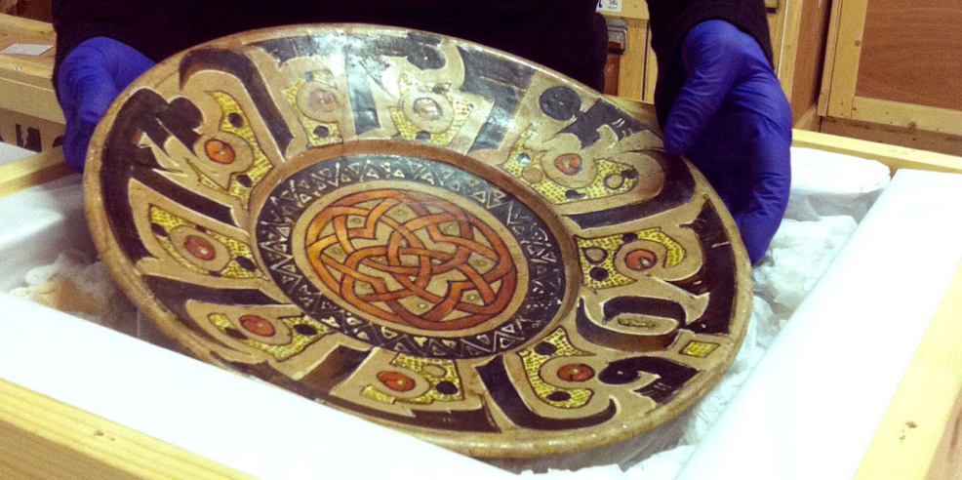

Decorative plate being uncrated from a box by a staff member at the Aga Khan Museum.
Sometimes, museums call the identification labels tombstone labels. Ask: Why do you suppose the labels are called that name?
This is the museum identification label for the astrolabe that we have been exploring:
Planispheric Astrolabe
Accession Number: AKM611
Date: 1300s
Place: Spain (Historic al-Andalus)

Lead the class in a discussion about how the museum identification label works, and how to gather its information. Suggested questions and answers:
Q: What is its name?
A: Planispheric Astrolabe

Q: How does the Museum keep track of it?
A: AKM611 (uses a numbering system)

Q: When was it made?
A: 1300s

Q: Where is it from?
A: Spain (Historic al-Andalus)

The second piece of information about this artefact that can be found on the Museum’s website is the museum commentary.

Teacher Notes
Model how to create
jot notes if necessary.

Jot Notes should:
- help to reveal ways
of life;
- help to reveal
information about
the environment;
- help me to
understand the
interrelationship between ways
of life and the environment.

Provide students with opportunities to
practice gathering information from the museum identification
label, and from the
museum commentary.

Model using the co-constructed organizer
and guide students as
they work towards independence.

Criteria for the
organizer should be
made into an anchor
chart that is posted
in the classroom for reference.

Criteria for the
organizer should also
consider whether
questions been
formulated according
to the criteria for interrelationships.

Sample A2 Gathering
and Organizing
Information organizer
is provided, below.

Museum Commentary
A museum commentary is a piece of text composed by a museum writer to help the audience learn more about an artefact.
The museum commentary for the astrolabe can be found here:
https://www.agakhanmuseum.org/collection/artifact/planispheric-astrolabe

Lead a class discussion about the museum commentary of the astrolabe, including some of the similarities and differences of identification labels and commentaries (in museum commentaries, the writer gets to choose what (s)he would like to share about the artefact).
Allow time for students to create jot notes on their artefacts. Encourage students to use the criteria on interrelationships:
- aspects of ways of life
- information about the environment
- aspects of the interrelationship between ways of life and the environment

Gathering and Organizing Information for an Inquiry
Students are ready to begin to gather and organize information on their artefacts to assist them in answering their inquiries.
Co-create an anchor chart for gathering and organizing information. Potential sources include:
- observations about the artefact (including the wonderings and questions from their Organizers);
- Museum Identification Labels;
- jot notes from Museum Commentaries.

Students can use A2 Gathering and Organizing Information to create an organizer for their information. Suggest that students
may complete their organizers electronically or in writing.

When finished, students should share completed organizers with a classmate and provide each other with feedback.
Students submit their organizers to the teacher after they have revised their work according to peer feedback.

Investigating Early Societies through the AGA KHAN MUSEUM
A2: Gathering and Organizing Information
What is the interrelationship between life and the environment in early societies?
Artefact:
Observation 1: What do you see? What makes you say that? What does it make you wonder?

Observation 2: What do you see? What makes you say that? What does it make you wonder?

Observation 3: What do you see? What makes you say that? What does it make you wonder?

Questions
Consider…Does your question seek to reveal ways of life; information about the environment and/or aspects of the interrelationship between ways of life and the environment?

Question 1:

Question 2:

Question 3:

Museum Identification Label
Museum Commentary

Additional information/questions

Consolidation
Exit Card

Students answer the following questions in writing as a Consolidation Task.

- How did using the Anticipation Guide help you think about and select an artefact from the Aga Khan Museum Collection for your inquiry?

- Why is it important to establish criteria for gathering and organizing your information?

- How did the criteria for establishing and organizing information help you to provide and receive feedback with a peer?

Collect Exit Cards when completed.

Lesson 3:

Evidence

Learning Goal
- We are learning to interpret and
analyse
information,
according to
criteria, to help
determine
evidence..

Suggested Success Criteria

I know I am successful
when I can:

- interpret and
analyse
information
regarding
early societies
and the
environment;
- use criteria for the
Social Studies
Thinking Concept, Interrelationships
to determine
evidence.

Curriculum Expectations
- A2, A2.4

Minds On

Students have gathered and organized some information about
an artefact they have chosen from the Aga Khan Museum’s collection. In this lesson, students will interpret and analyse their information to help answer the question:

What is the interrelationship between life and the environment in early societies?
Distribute the graphic organizer A3 My Evidence to each student.

Model how to interpret and analyse information using the information that students generated during the discussion on the Planispheric Astrolabe (AKM611) in Lesson 2: Gathering and Organizing Information about Early Societies.

Students can follow along by referring to their organizer to see how to use the criteria on interrelationships when interpreting and analyzing information.

Action

Suggest that students interpret and analyse the information they have gathered about their artefacts with an elbow partner or peer.

Get volunteers to share some examples of their analyses following the partner work. Class discussion on interpretation and
analysis should focus on the following questions:
- How does your information reveal ways of life?
- How does your information reveal something about the
environment?
- How does your information reveal the interrelationship between ways of life and the environment?

Reinforce to students that when their interpretation and analysis of information meets the criteria, the information can become evidence.

Teacher Notes

Minds On
The purpose of
Minds On is to
prepare students for
their interpretation
and analysis.

Modeling the use
of the A3 My Evidence organizer using
information on the Planispheric Astrolabe
can be done through
direct instruction or
through a think-aloud,
with opportunities for students to ask
questions. Also,
demonstrate how information, when
aligned with the
criteria, becomes
evidence.

Action
When sharing with a partner, students
should be able to recall
the following
information for interpretation
and analysis:
- their observations;
- their wonderings;
- their inferences;
- the questions they formulated;
- the museum identification label information;
- the museum commentary information.

Investigating Early Societies through the AGA KHAN MUSEUM
A3: My Evidence
Artefact:
Criteria for  Interrelationships | What is the evidence? | Questions I Still Have…
The artefact
reveals ways of life

The artefact
reveals information
about the environment.

The artefact
reveals information
about the
interrelationship
between ways of life and
the environment
Where will I look for additional info?

Investigating Early Societies through the AGA KHAN MUSEUM

Peer Feedback provided to ______________________________________________

- Where am I going?
- You have listed evidence for each criterion.

- You have stated questions you still have.

- You have listed additional opportunities to look for further information.

- How am I doing?
- Your evidence meets the criterion.

- Your evidence does not meet the criterion.

- Your questions show interest in learning more.

- Your ideas for locating additional information are detailed.

- Where to next?
- Revisit the information that you have gathered and organized to find further evidence.

- Make sure your evidence matches the criterion.
- Revise your questions to help find further evidence.
- Add more details to your additional information section.
- Ask your teacher or a peer about how and where to locate additional information.

Peer Feedback provided by ______________________________________________

Teacher Notes

Minds On
The purpose of
Minds On is to
prepare students for
their interpretation
and analysis.

Modeling the use
of the A3 My Evidence organizer using
information on the Planispheric Astrolabe
can be done through
direct instruction or
through a think-aloud,
with opportunities for students to ask
questions. Also,
demonstrate how information, when
aligned with the
criteria, becomes
evidence.

Action
When sharing with a partner, students
should be able to recall
the following
information for interpretation
and analysis:
- their observations;
- their wonderings;
- their inferences;
- the questions they formulated;
- the museum identification label information;
- the museum commentary information.

Class discussion on interpretation and
analysis should
focus on the following questions:

- How does your information reveal ways of life?
- How does your information reveal something about the environment?
- How does your information reveal the interrelationship between ways of life and the environment?

Co-construct choices about where to look for additional evidence to support students’ inquiry. Create and post an anchor chart of these choices for students to reference.

Responses may include:

- Conduct additional research from the Aga Khan Museum website.
- Consult the research from the work of my peers (including the Planispheric Astrolabe).
- Consult other sources (books, websites, etc.).

Allow students time to complete the A3 My Evidence graphic organizer and receive peer feedback.

Once students have incorporated the feedback, add additional information where needed, they should submit their organizers for review.

Consolidation
Class Discussion

Discuss the following points with the whole class.

- Why is it important to use criteria for interpreting and analysing information?

- How does the criteria established for interrelationships help you to determine evidence when interpreting and analysing?

- What is becoming clearer to you based on your interpretation and analysis of the ways of life in early societies and the environment? In what area(s) would you like to find out more information?

* Optional: Consider establishing a bulletin board that captures student learning throughout the social studies inquiry process.

Teacher Notes

When looking for
additional information, students will need
explicit instruction
on how to conduct an effective internet
search. Providing
students with tips on
how to use the right
wording to generate
the information they
need from internet
searches, caution about trustworthy websites,
and search engines
other than just Google
will be beneficial. See:
http://mediasmarts.ca/ tipsheet/ how-search-internet-effectively

Provide students
with pre-approved w
ebsites, library
databases, or search
engines that cater to children. Model a
search for students.
The following search
engines may prove
useful and were
designed for children:
www.kidrex.org
www.ipl.com

